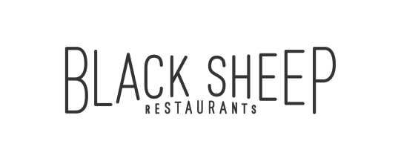

Black Sheep Restaurants is a Hong Kong-based hospitality group that specialises in developing niche, thought-provoking restaurant concepts that add to the existing culinary dialogue.

Whether recreating popular international concepts for the Hong Kong market or developing standalone restaurants, Black Sheep Restaurants curates distinct dining experiences that tell a story about a particular time, place, culture or cuisine while celebrating the bounty of premium ingredients available both locally and from abroad. The group currently boasts a portfolio of thirteen restaurants and bars, including Chôm Chôm, Motorino (Soho & Wan Chai), La Vache!, Ho Lee Fook, Carbone, Burger Circus, Stazione Novella, Le Garçon Saigon, BELON, Maison Libanaise, Buenos Aires Polo Club and Soul Food.

**IT Administrator**

**Main Responsibilities**

* Responsible for day-to-day support, troubleshooting and solutions to IT-related issues, network, software and hardware
* Provide support for backup procedures, email service, networking, server operation, website modification, installation and configuration of different IT equipment
* Deliver in-house and off-site technical support including troubleshooting, resolution and escalation to the office and restaurants
* Perform hardware and software asset management
* Handle administrative tasks including active directory management, user account/email account creation and group policy modifications
* Report directly to the Human Resources and Administration department

**Requirements**

* Degree in Computer Science, Information Technology or related discipline
* At least two years of relevant experience; Food & Beverage experience is a plus
* Hands-on experience with hardware and software administration and recovery on:
* Microsoft Windows Environment (e.g. Windows 10, Windows Server, MS Office suite etc)
* Apple Mac OS Environment (e.g. Macbook, iPad, iPhone etc)
* Networking (e.g. knowledge of LAN, WAN, TCP/IP, switch /router support and configuration)
* Programming Language (e.g. HTML, PHP, MySQL)
* In-depth knowledge of Windows 2012 server administration
* Knowledge in POS (Restaurant and Online Database) is a plus
* Understanding of implementation and administration of office365
* Troubleshooting and user support skills for PC hardware/Network and software
* Certificates holder of industry certifications is a plus (i.e. Microsoft, Cisco, VMWare, etc)
* Good command in written and spoken English and Cantonese
* A team player with good communication, interpersonal, analytical and problem solving skills
* Able to work independently and multi-task with tight deadlines

**BENEFITS**

* Competitive salary
* Quarterly discretional bonus
* 5 days work
* Staff discount
* Medical scheme
* Education sponsorship program
* Related training provided
* Discounted gymnastic membership program

Interested candidates please send their resume with **CURRENT and EXPECTED** salary to: [careers@blacksheeprestaurants.com](mailto:careers@blacksheeprestaurants.com) or contact our HR Team at 2810 0062 if you have any inquiries.

*(All personal information collected would be kept strictly confidential and for recruitment purposes only.)*